**Présentation Application STUDENT NOTEBOOK**

**Main Idea of the project :**

We plan to create an application used as Notepad that will allow a student to create notes, record the voices during his lectures, allow him during that recording to take some pictures too and the application will allow the student to put some bookmarks on the recording that he is doing.

The point is that this application is very appropriate from Evernote and many other applications we can find on play store but the main point that we will try to approach in our project will be to have those functionalities accessible at the same time. So, we will be able to capture photos, record sound and add bookmarks simultaneously.

Here we have a little example of how may look our application:

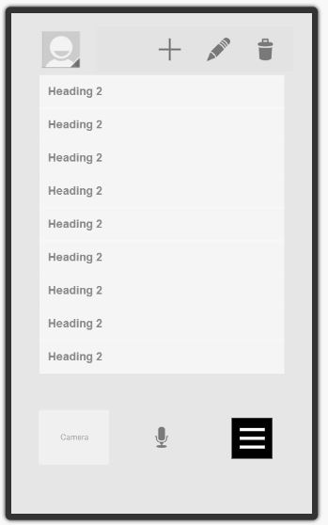

The tasks for this application will be the following :

1. The camera recording
2. the voice Recording
3. The Bookmarks
4. The user interface